

Azure Site Recovery (ASR) Deployment Guide
VMware vSphere Environments

10th Magnitude, LLC
20 North Wacker Drive #530
Chicago, IL 60606

Notice of Confidentiality © 2018 10th Magnitude, LLC All rights reserved

THIS DOCUMENT IS 10TH MAGNITUDE PROPRIETARY AND CONFIDENTIAL INFORMATION AND IS SUBJECT TO THE TERMS OF THE 10TH MAGNITUDE NON-DISCLOSURE AGREEMENT. NEITHER THIS DOCUMENT NOR ITS CONTENTS MAY BE REVEALED OR DISCLOSED TO UNAUTHORIZED PERSONS OR SENT OUTSIDE THE AFOREMENTIONED COMPANY WITHOUT PRIOR PERMISSION FROM 10TH MAGNITUDE.
Table of Contents
Summary 3
ASR Deployment 3
Prepare On-Prem and Azure Environments 3
Deploy the Configuration Server 4

Summary
This is a general high-level step-by-step guide for deploying Azure Site Recover (ASR) components in a VMware specific on-prem environment.

ASR Deployment
Before you start, it’s a good idea to review 10th Magnitude’s ASR Planning Guide and the Microsoft ASR Setup Guide to get a clear understanding of the architecture and what needs to be deployed to support the migration.

Useful reference links:
https://docs.microsoft.com/en-us/azure/cloud-solution-provider/migration/on-premises-to-azure-csp/asr-capacity-planning
https://docs.microsoft.com/en-us/azure/cloud-solution-provider/migration/on-premises-to-azure-csp/asr-setup-guide
https://docs.vmware.com/en/VMware-vSphere/6.5/com.vmware.vsphere.vm_admin.doc/GUID-17BEDA21-43F6-41F4-8FB2-E01D275FE9B4.html

Note: If multiple vCenter servers will need to be connected, a Configuration Server and Recovery Services Vault may need to be created for each vCenter instance.

Prepare On-Prem and Azure Environments

- A service account will need to be created in the on-prem environment to connect to vCenter or the ESXi host(s) for automatic discovery. The account will need at least the following permissions granted on the vCenter or ESXi host(s):

Task | Account | Permissions
Automatic discovery/Migrate (without failback) | You need at least a read-only user | - Data Center object –> Propagate to Child Object, Role=Read-only
Replication/Failover | You need at least a read-only user | - Data Center object –> Propagate to Child Object, Role=Read-only
Replication/failover/failback | We suggest you create a role (AzureSiteRecoveryRole) with the required permissions, and then assign the role to a VMware user or group | - Data Center object –> Propagate to Child Object, role=AzureSiteRecoveryRole  - Datastore -> Allocate space, browse datastore, low-level file operations, remove file, update virtual machine files  - Network -> Network assign  - Resource -> Assign VM to resource pool, migrate powered off VM, migrate powered on VM  - Tasks -> Create task, update task  - Virtual machine -> Configuration  - Virtual machine -> Interact -> answer question, device connection, configure CD media, configure floppy media, power off, power on, VMware tools install  - Virtual machine -> Inventory -> Create, register, unregister  - Virtual machine -> Provisioning -> Allow virtual machine download, allow virtual machine files upload  - Virtual machine -> Snapshots -> Remove snapshots

- The on-prem migration service account will need local administrator permissions on the source servers that will be migrated to install the mobility service – optionally a second service account with these rights can be provisioned.
- Create Resource Group in each target subscription for the Recovery Service Vault(s)
- Create a Recovery Services Vault in the target region(s)
  - Sign into the Azure Portal
  - Select New > Management > Backup and Site Recovery
  - Create a name to convention, select the correct Subscription and Resource Group, select the correct target location
  - Optionally select pin to dashboard for quick navigation back

Deploy the Configuration Server
Use the following steps to deploy ASR Configuration Server components and connect to the on-prem infrastructure.

- Start the setup from Azure
  - In the Azure portal, open the Recovery Service vault
  - In the Site Recovery section, click Getting Started, then Prepare Infrastructure

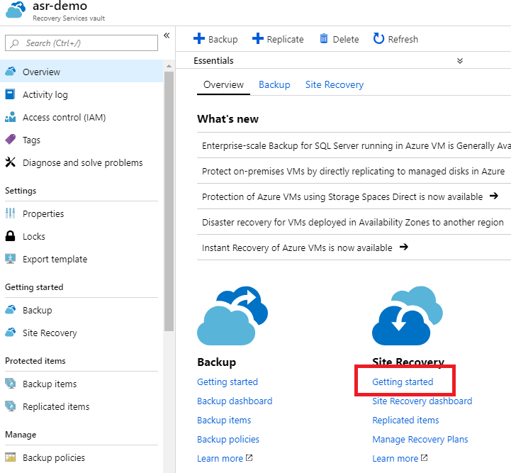

  - In the Protection goal step > Where are your machines located, select On-premises. Where do you want to replicate your machines, select To Azure. Are your machines virtualized, select Yes, with VMware vSphere Hypervisor. Click OK.
  - Deployment Planning > Yes, I have done it. Click OK.

  - Source > Click + Configuration Server, then Download to download the OVF template. Since this is a large file (20GB+), you should provide the link to the customer to download directly into their source environment.

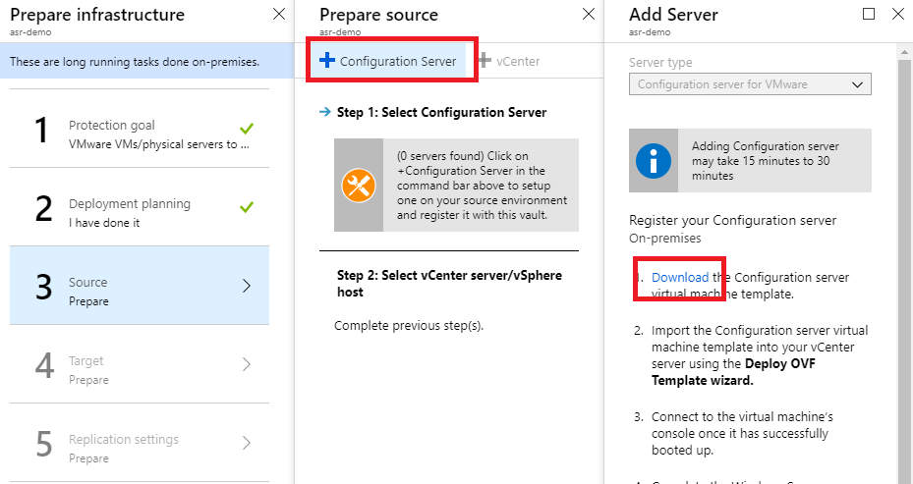

- Deploy the OVF template into the VMware environment.
  - Log into vCenter server
  - Right-click any inventory object that is a valid parent object of a virtual machine, such as a data center, folder, cluster, resource pool, or host, and select Deploy OVF Template. The Deploy OVF Template wizard opens.
  - On the Select an OVF template page, specify the location of the source OVF or OVA template and click Next.
  - On the Select a name and folder page, enter a unique name for the virtual machine or vAPP, select a deployment location, and click Next.
  - On the Select a compute resource page, select a resource where to run the deployed VM template, and click Next.
  - On the Review details page, verify the OVF or OVA template details and click Next.
  - On the Select storage page, define where and how to store the files for the deployed OVF or OVA template. Make sure to select a datastore large enough to accommodate the virtual machine or vApp and all associated virtual disk files.
    - Select the disk format for the virtual machine virtual disks. Use the default values from the template here.
    - Select a VM Storage Policy. This option is available only if storage policies are enabled on the destination resource.
    - (Optional) Enable the Show datastores from Storage DRS clusters check box to choose individual datastores from Storage DRS clusters for the initial placement of the virtual machine. Select a datastore to store the deployed OVF or OVA template.
  - On the Select networks page, select a source network and map it to a destination network. Click Next.
  - On the Ready to complete page, review the page and click Finish.
- After the template is deployed, boot the VM and connect to the VMs console to complete the Windows Server installation.
- Finish setting up the server to desired specifications – join to the domain, run Windows Update, etc. It is important to keep this server up-to-date or the services may stop.
- Launch the ASR Configuration Manager wizard from the link on the desktop. Run through the wizard and fill in the required information to register the server with the Recovery Services Vault. It can take 15-30 minutes for the Configuration Server to show up in the vault.
- Go back to the Recovery Services Vault unified setup in Step 1 and go through the wizard again. On Source step, verify you see the configuration server listed and select it, then select whether you are connecting to vCenter or vSphere hosts. If your Configuration Server isn’t listed, go back to the Recovery Vault landing page, click Site Recovery Infrastructure, Configuration Servers, click the ellipsis (…), and then select Refresh Server.
- On the Target step, select the correct subscription, use Resource Manager, and select the virtual networks.
- On the Replication Settings step, create a replication policy and click OK, then click OK again.

